

**30021 – Digital Instrumentation E19**

Exercise 2 – LCD, Flash, ADC

**Group - 6**

Joanna Krawczyk - s192515

Lokesh Kumar Kalimuthu Chandran - s192151

Daniel Levente Benyei - s192386

**Introduction**

The following experiment is performed to study the usage of LCD displays, Analog to Digital converters and calibration of measurements using a STM32F302R8 MCU embedded on a Nucleo development board.

**Abstract Subject**

The subject of this exercise is LCD display and analog to digital converter added to the mbed expansion board. The used LCD is monochrome dot matrix display made of 512 bytes, divided between 4 rows and SPI is used for communicating the data. Due to these properties, the LCD will be used to display particular messages after e.g. reading data from FLASH memory or measurements with the use of ADC.

**Exercise 2.1 – Writing data to the LCD**

**General description:**

The first part of exercise is focused on display of data after initializing SPI communication with it.

**Implementation:**

First, several libraries have been included. There are two new *string.h* and *lcd.h* which consist of functions for initializing the display and presenting different messages on it. As several functions are repeated by using both *lcd.h* and *30021_io.h*, in the second library those functions have been commented.

Work with LCD must begin with setting SPI connection. Next step is about defining an array. Its number of elements should be equal to the size of display. Then, *memset()* function have been used for assign the hexadecimal number 0x49 to the whole array. To present all array’s elements, *lcd_push_buffer()* function has been used. Explained code and steps of its programming are presented below.

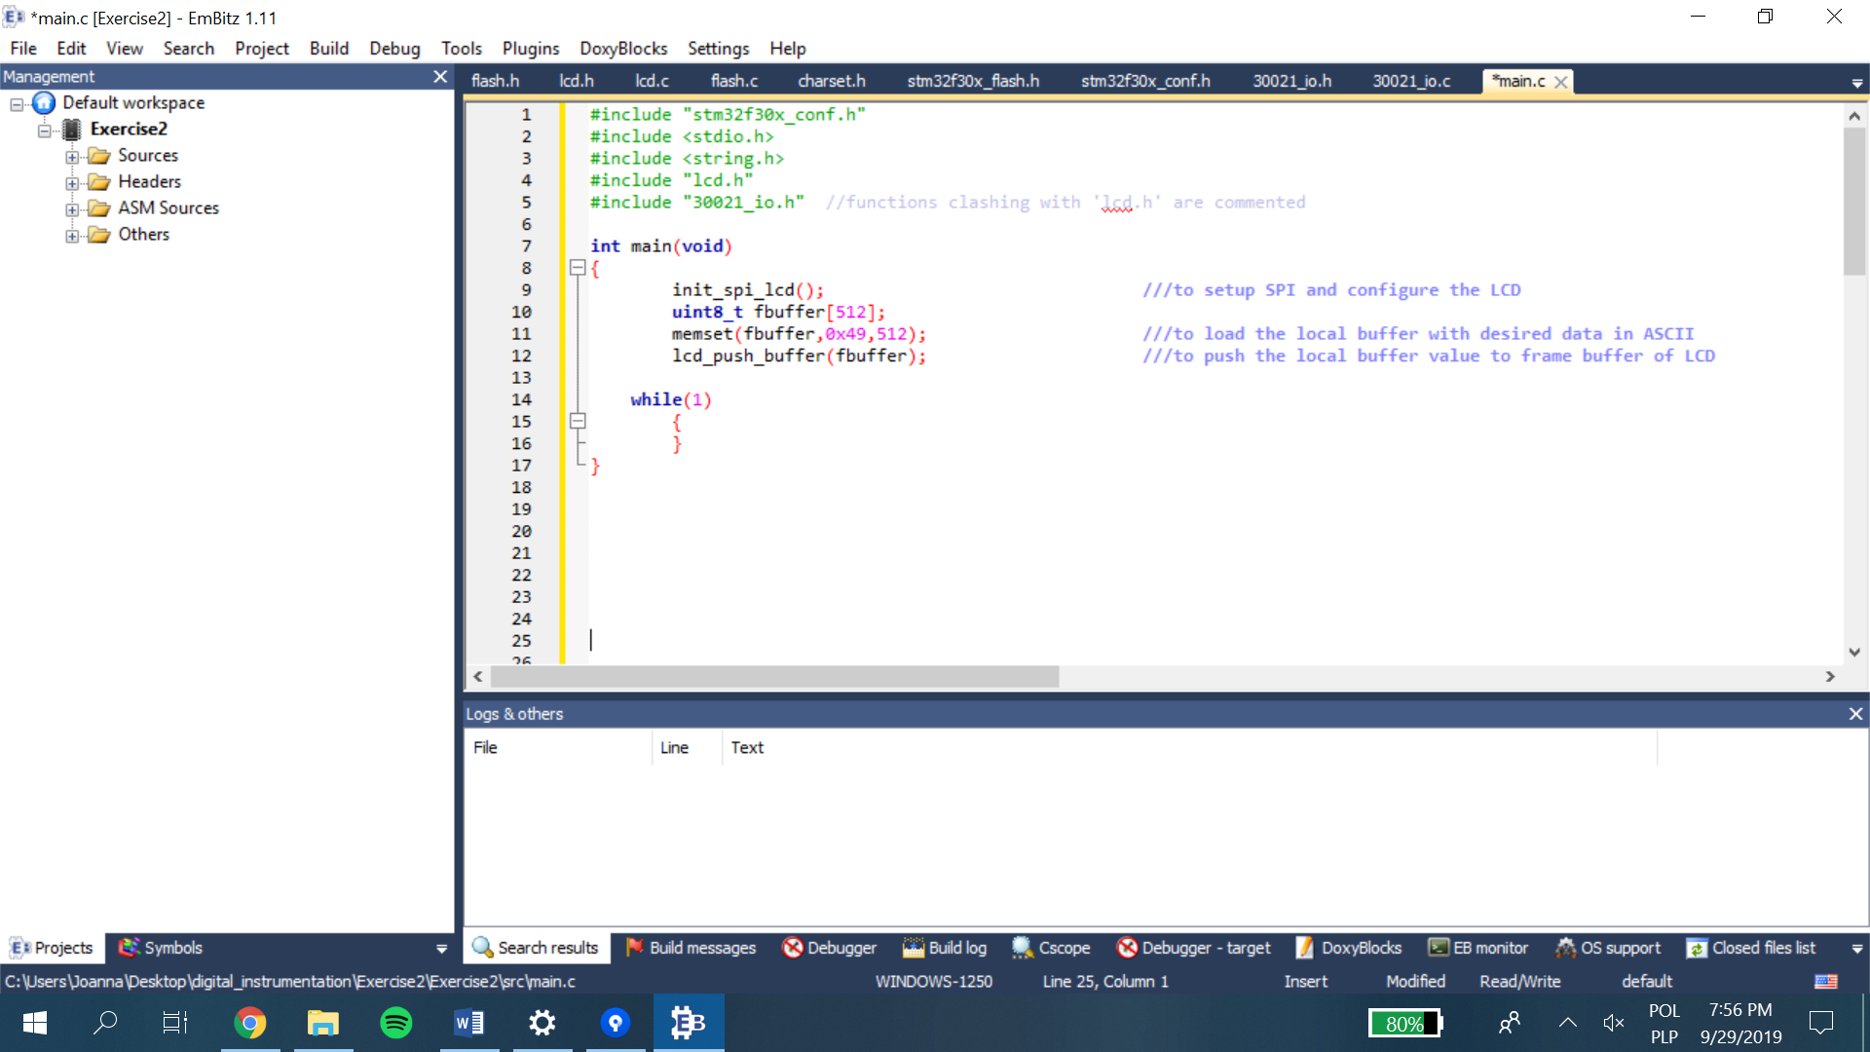

Code 1. Writing data to the LCD.

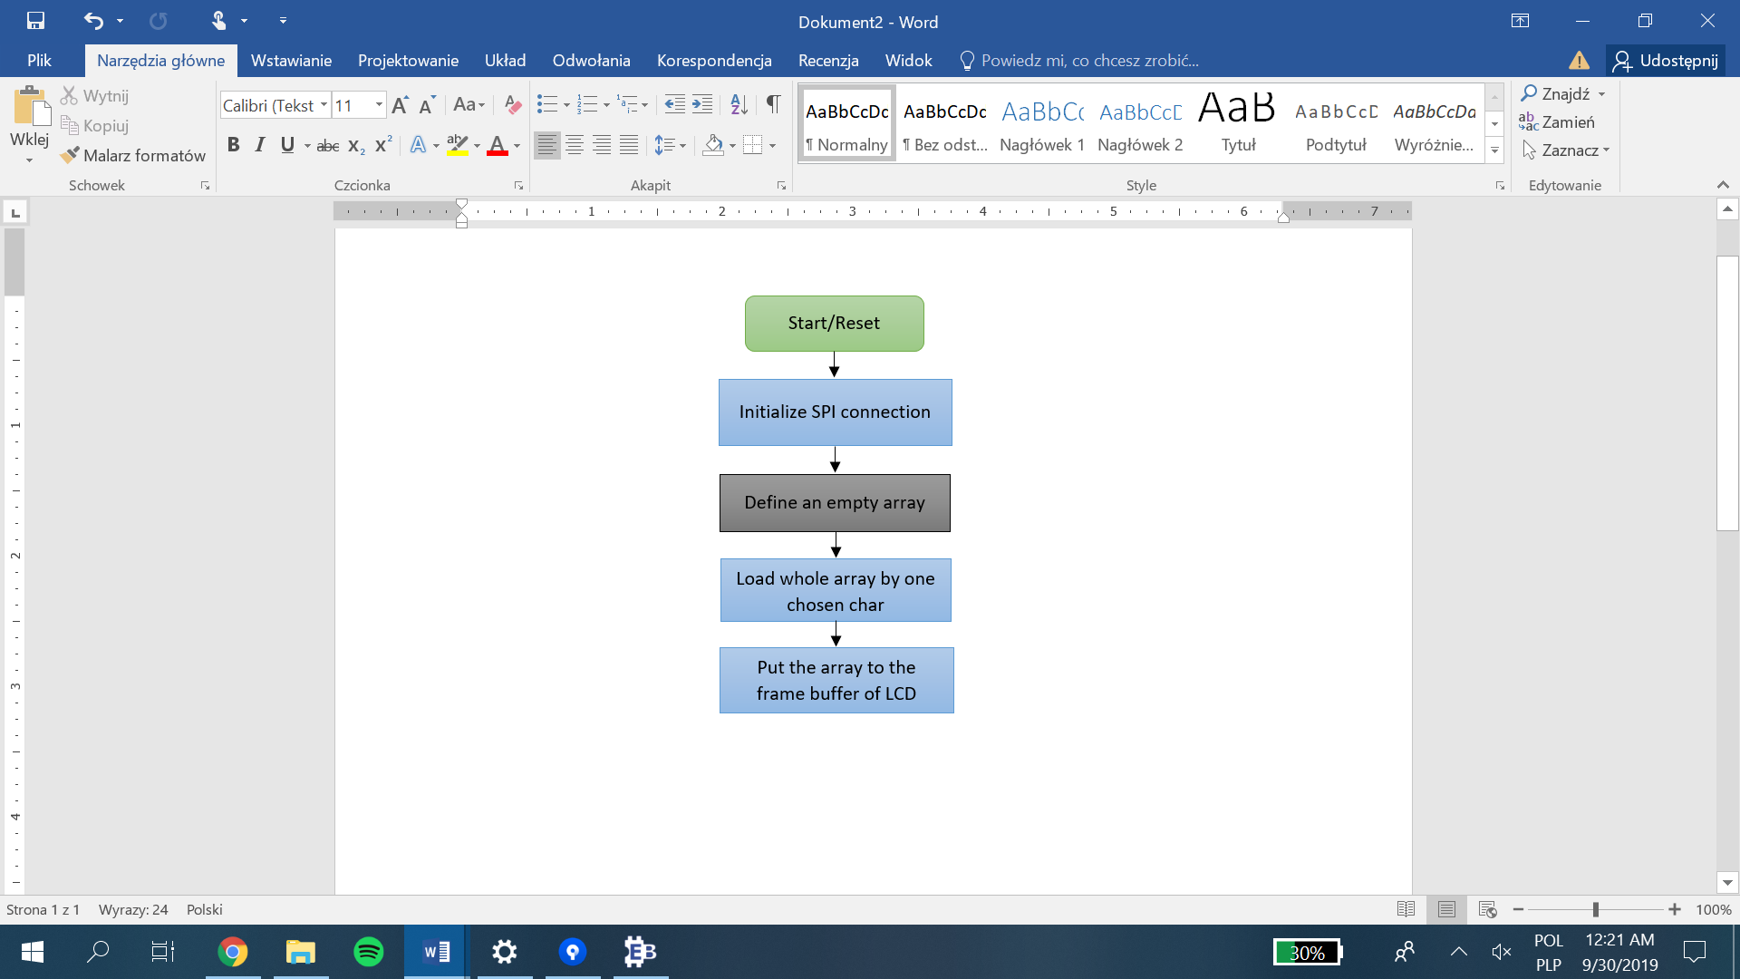

Char 1. Writing data to the LCD.

When an ASCII value of 0x49 was loaded and pushed into the LCD buffer, it resulted in an image shown on the following picture. Here, all the character elements are filled with the character-I that corresponds to the ASCII-0x49. Due to continuous refreshing, the character displayed was visible only as straight lines.

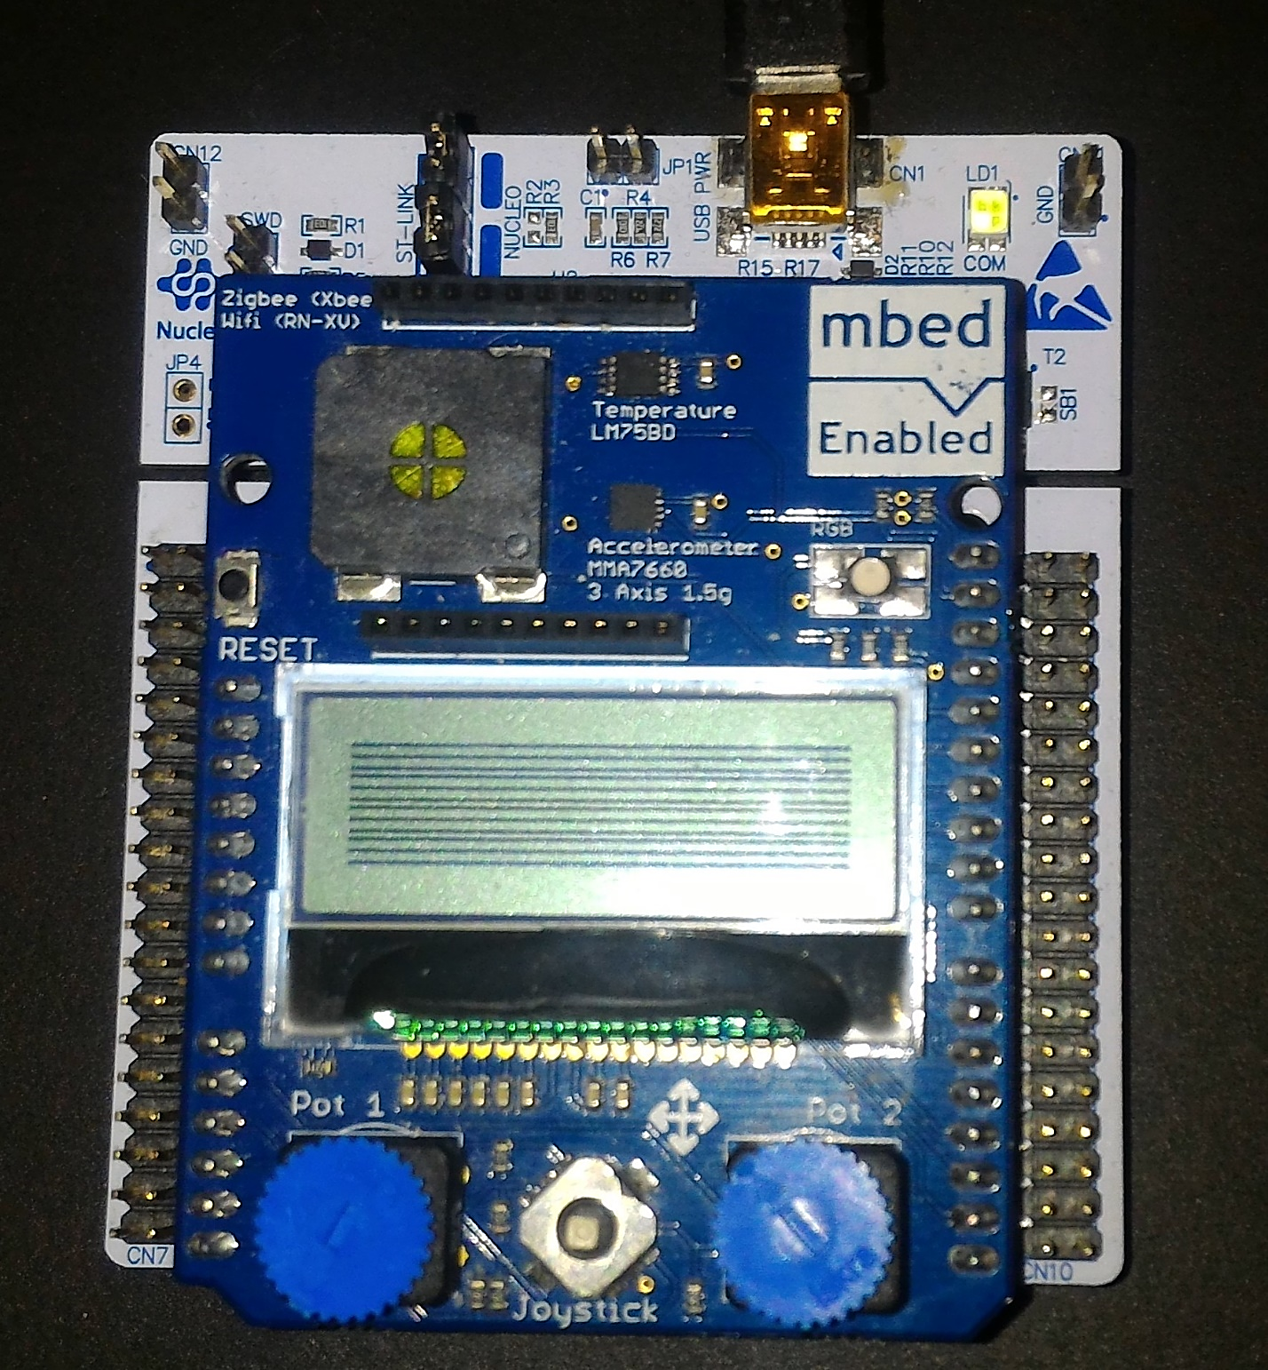

Picture 1. Result of writing data to the LCD.

**Exercise 2.2.1 – Writing strings on the LCD**

**Implementation:**

*The lcd.h* library enables also fast presentation of strings. As SPI conection is already set and *buffer* array is defined, it is enough to use *lcd_write_string()* function. This function requires array (to store written strings) and defined positions where the text should be displayed:

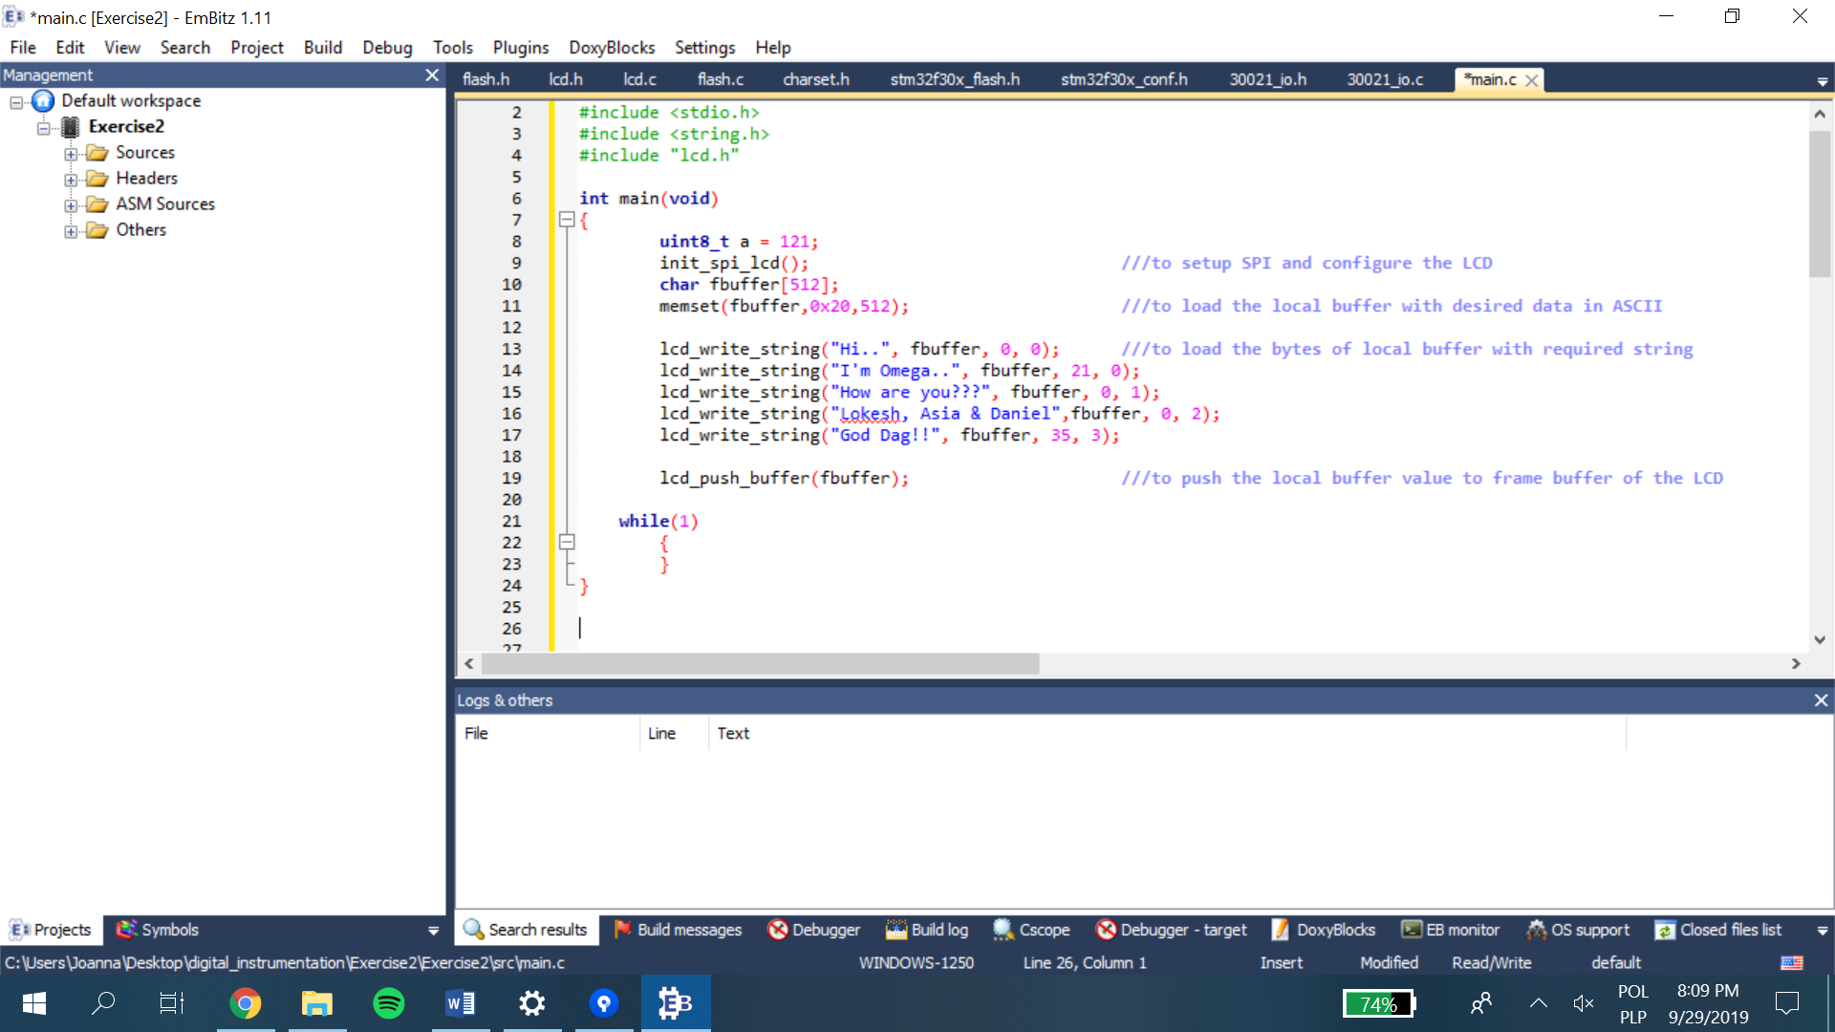

Code 2. Writing strings on the LCD.

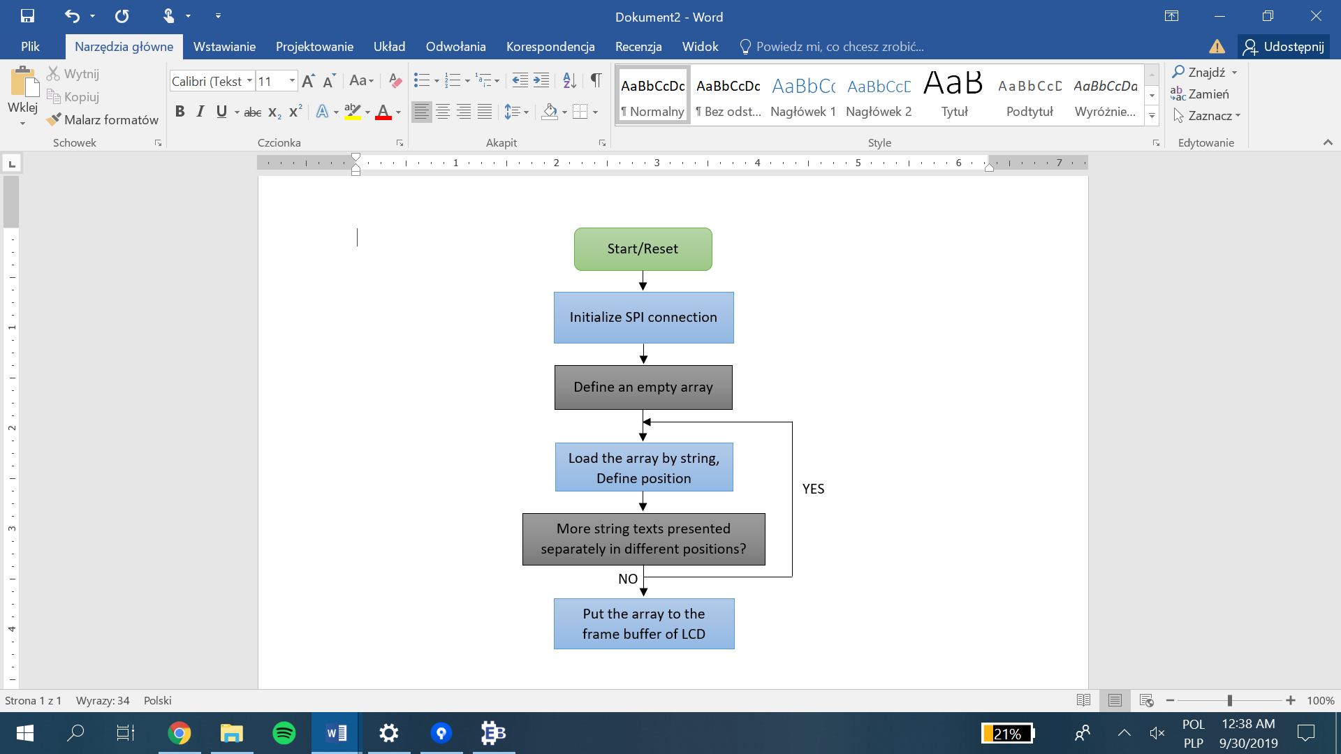

Char 2. Writing strings on the LCD.

Above code results in the following appearance on the LCD:

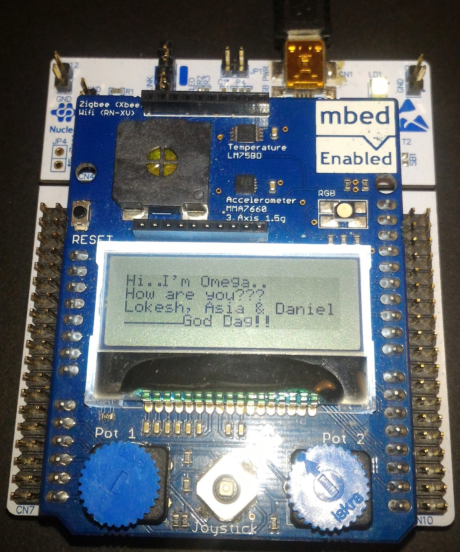

Picture 2. Result of writing strings to the LCD.

**Exercise 2.2.2 – FLASH memory**

**Implementation:**

To operate with the FLASH memory, library *flash.h* has been used. The library allows to write and read different types of variables to and from the memory. Firstly, however, FLASH memory needs   
to be unlock. Two next lines result in erased page. In this case, the written hexadecimal number for address means page 31.

The loop is written to increment new values so every next 16 bits store higher number to the previous one. To write all data to the memory page, *FLASH_ProgramHalfWord()* function has been used. After the loop operation is finished, FLASH memory should be protected by using *FLASH_Lock()* function.

The second loop operating on defined integer variable tempVal is added to read all written data. As UART has been initialized in the beginning, the *printf()* function has been called to check the correctness of previous loop.

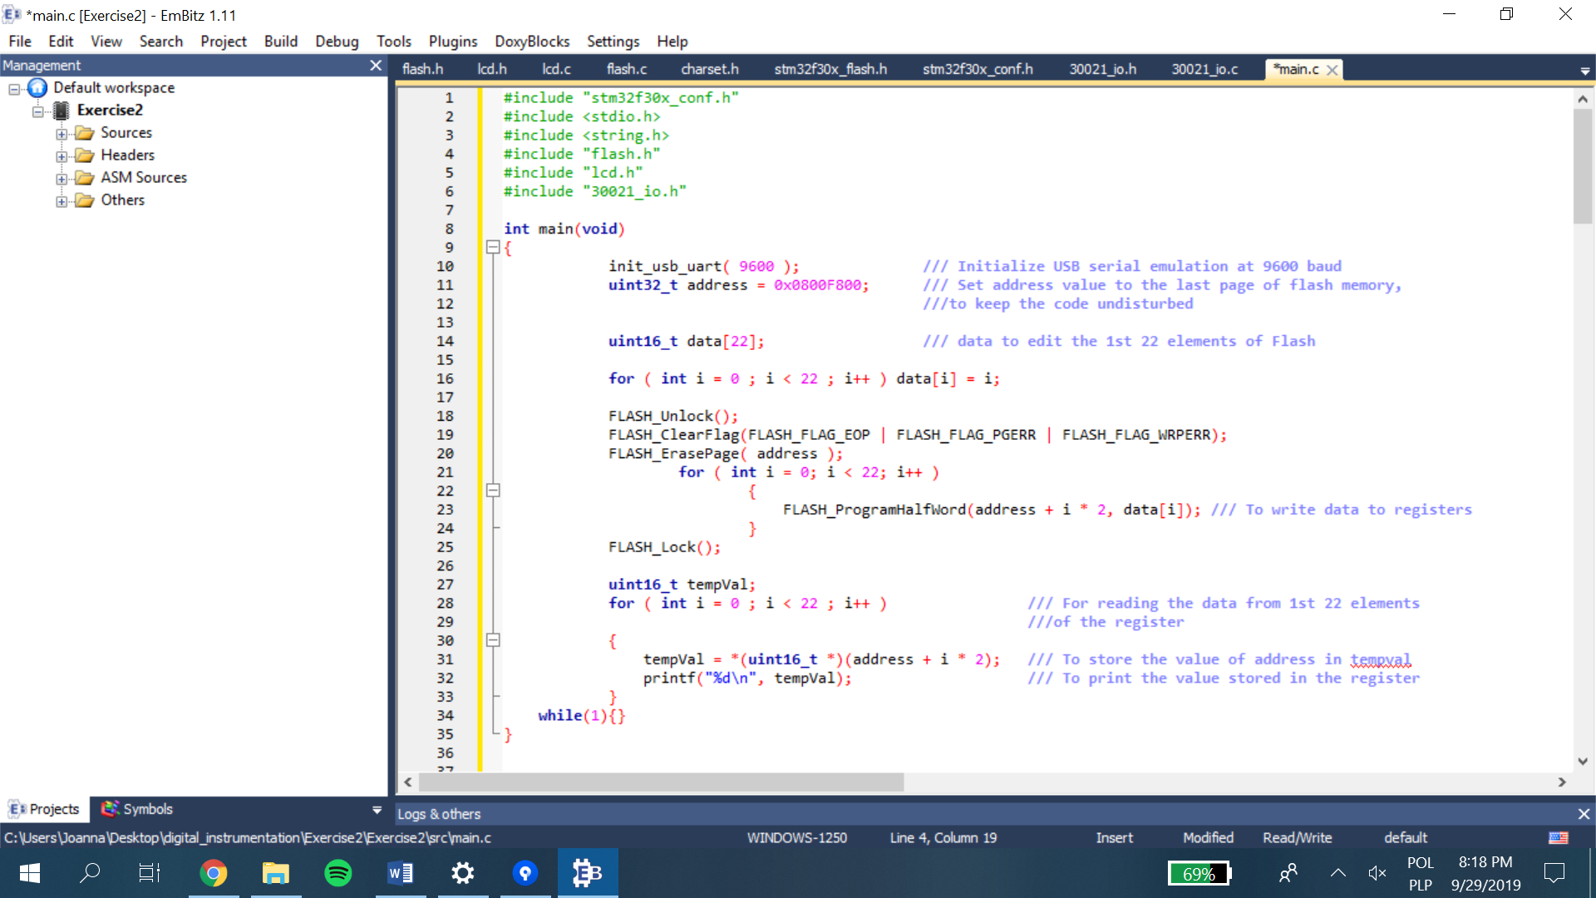

Code 3. Reading and writing data to the FLASH memory.

Results of writing increasing int16 variable type to the page 31 is presented on both PUTTY and Memory windows:

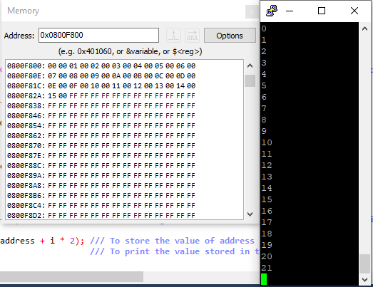

Picture 3. Results presented on the Examine Memory and PUTTY windows.

Below, a similar operation is programmed but the data integer is now 32 bits type (instead of 16). Again the loop *for()* is used to fill the page. This time, however, the data adress is changed for the recommended incremental patern which starts of 0x01010101. To write and read these type of integer variables, *write_word_flash()* and *read_hword_flash()* functions have been used.

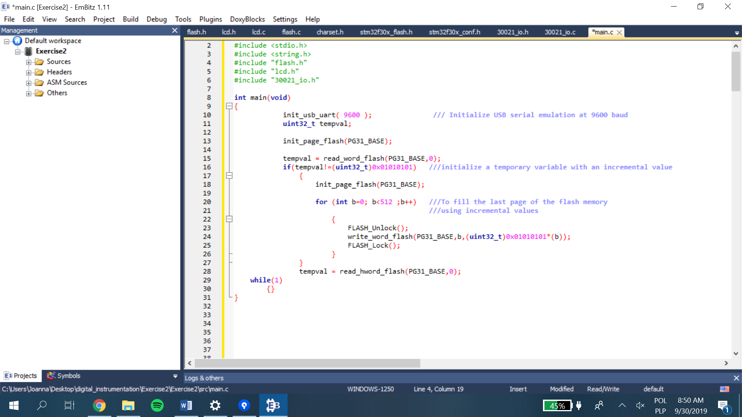

Code 4. Writing incrementing values to the FLASH memory.

The operation results are checked again by the Memory window:

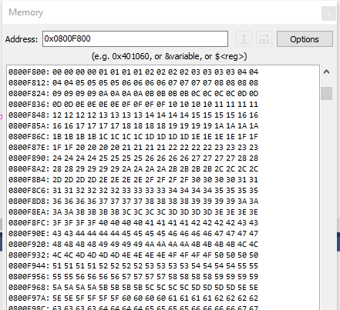

Picture 4. Results presented on the Examine Memory.

The last program of working with FLASH memory shows how to write/read float types. To do this, two other functions have been used: *read_float_flash()* and *write_float_flash()*. The overall seqence of actions is still the same:

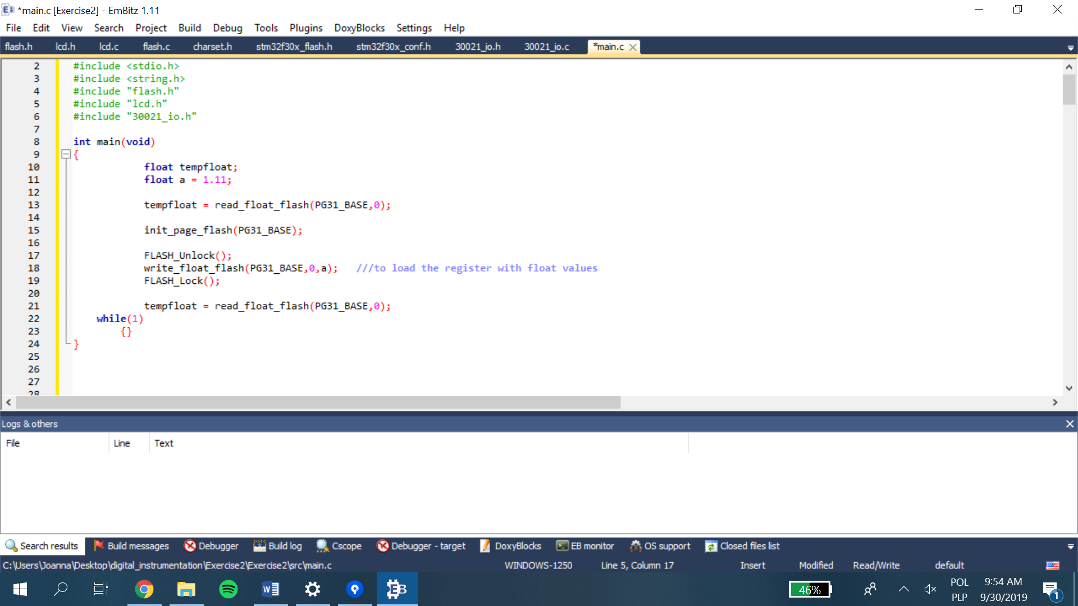

Code 5. Writing float values to the FLASH memory.

For the float number given, 1.11, its hexadecimal equivalent 0x3F8E147B, is written in the registers at the address 0x0800F800.

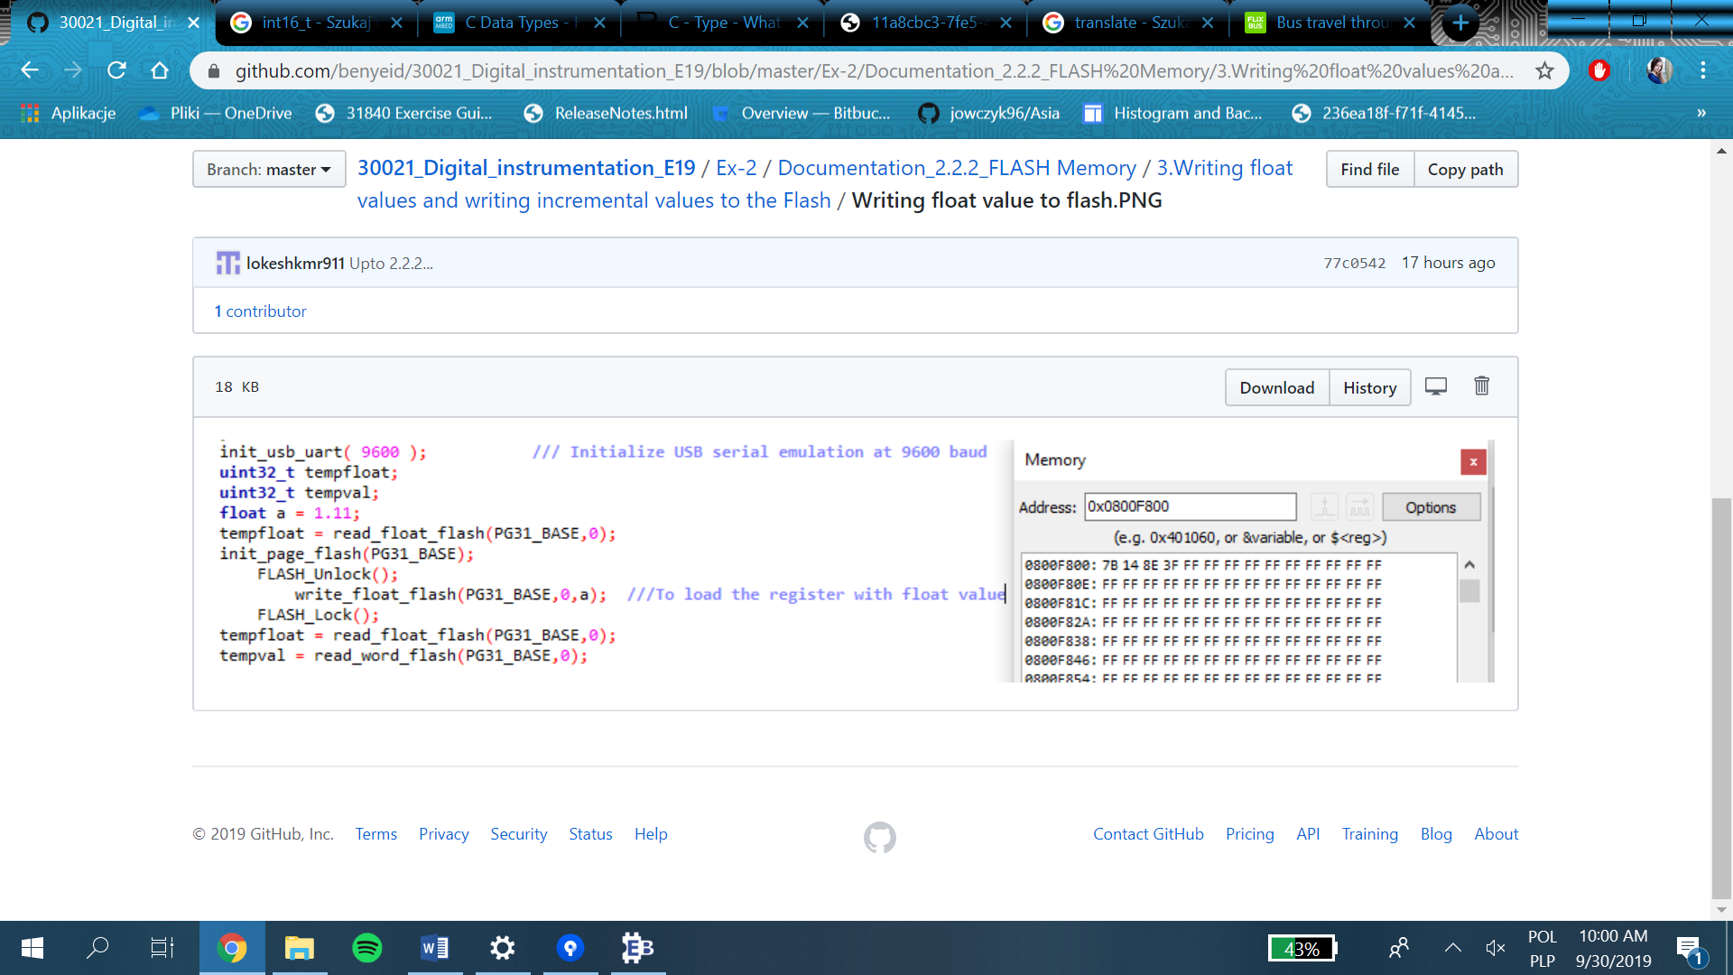

Picture 5. Results presented on the Examine Memory.

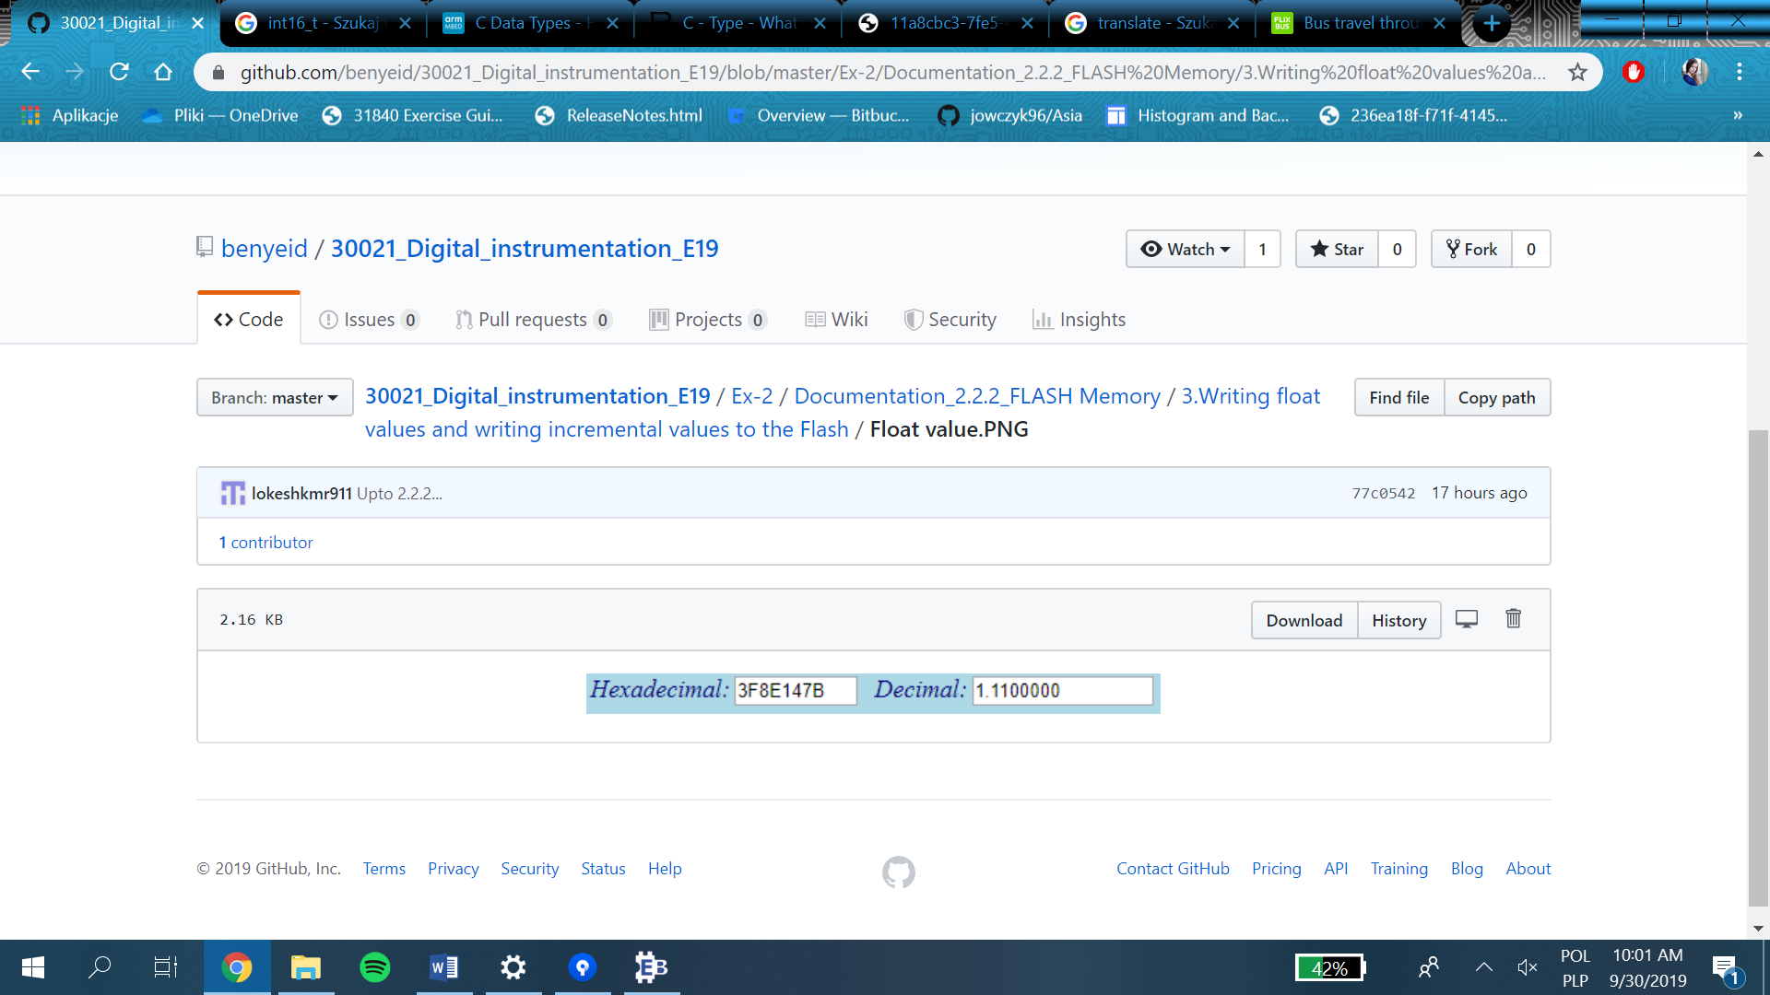

Picture 6. Converted number.

According to similarities between reading/writing different types of variables, a general chart is presented below:

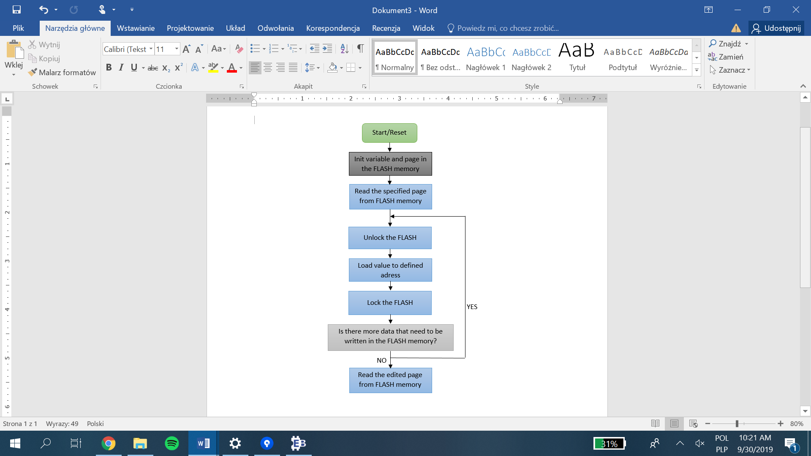

Char 3. Loading and reading data from FLASH memory.

**Exercise 2.2.3 – Analog-to-Digital Conversion**

**General description:**

The purpose of this experiment is to use the built in Analog to Digital Converter to read the analog voltage as inputs A0 and A1, and display both the voltages accurately. In practice, the measured voltage value should be presented in the display. Moreover, two potentiometers are used to adjust the measurement at input ports A0 and A1 of ADC.

**Implementation:**

Potentiometers are connected to PA0 and PA1 so the first commands apply to these pins settings. Both pins are set as inputs:

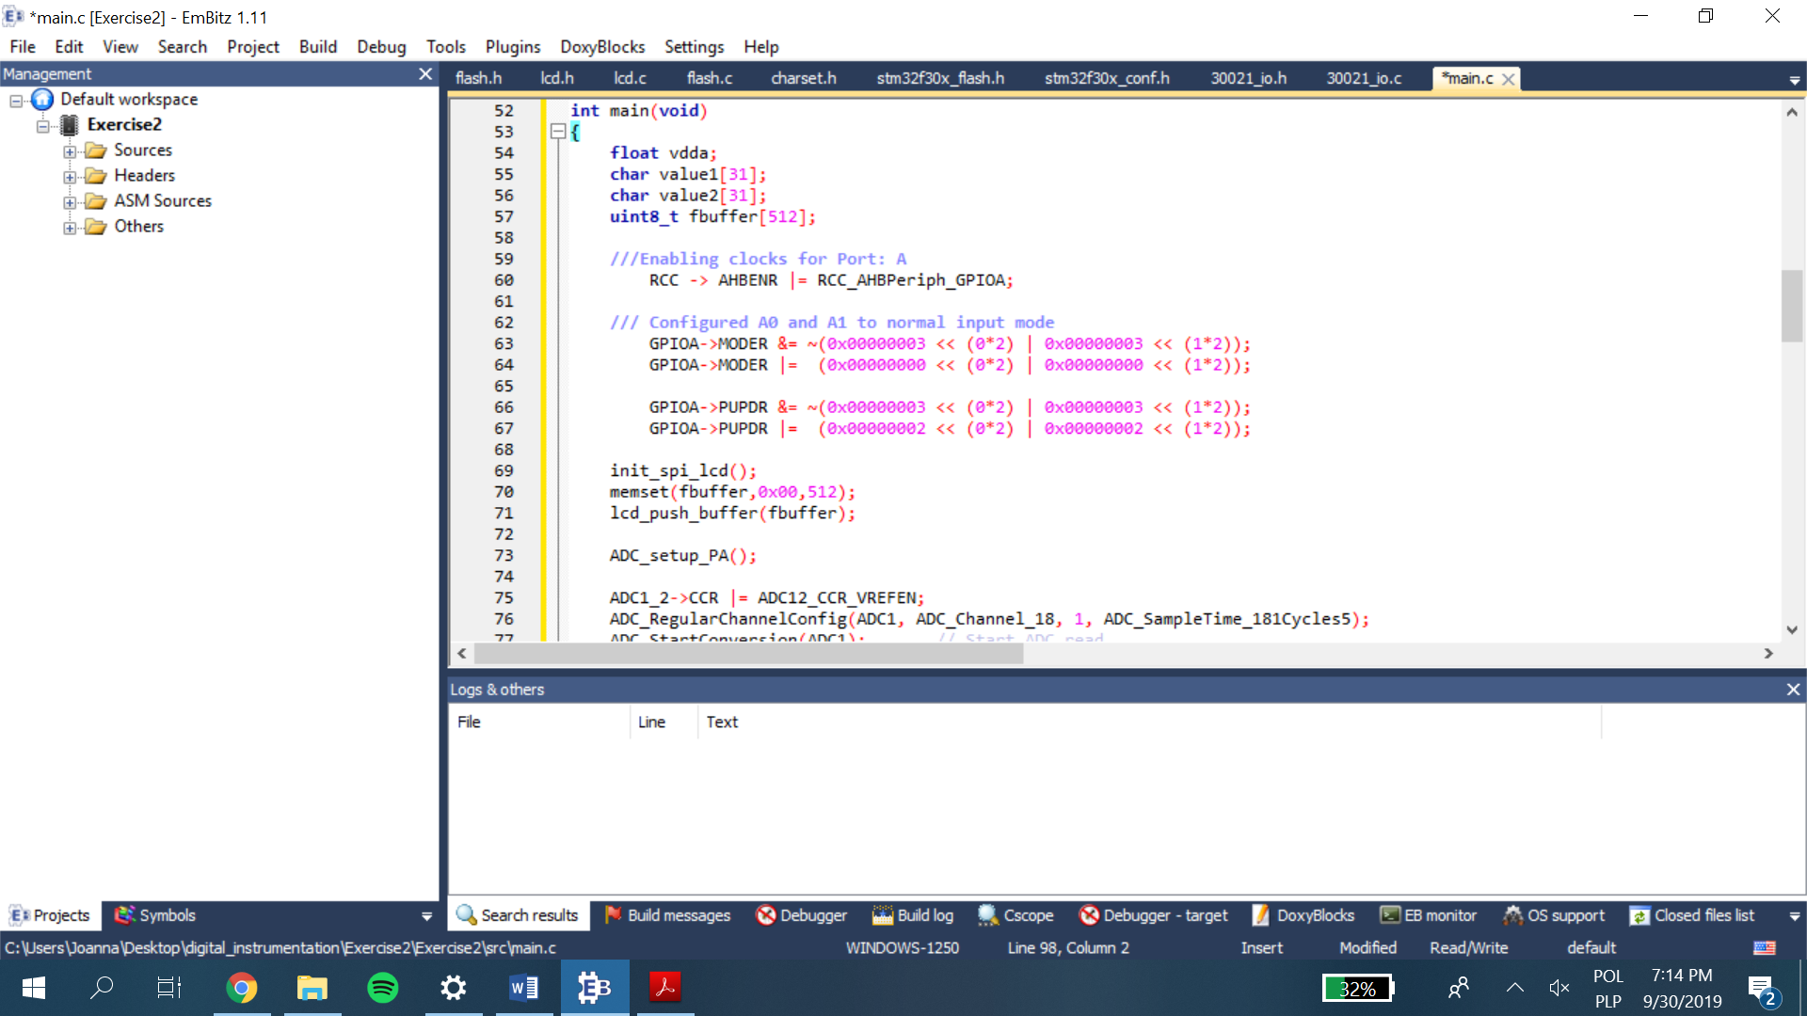

Code 7. Configuration of PA0 & PA1

To configurate builded ADC, an *ADC_setup_PA()* function have been written. This function sets prescaler value to get 8MHz clock frequency and enables counting. Next, there is a strict configuration of ADC which is mainly done by using CR register. Whole function’s body is presented below:

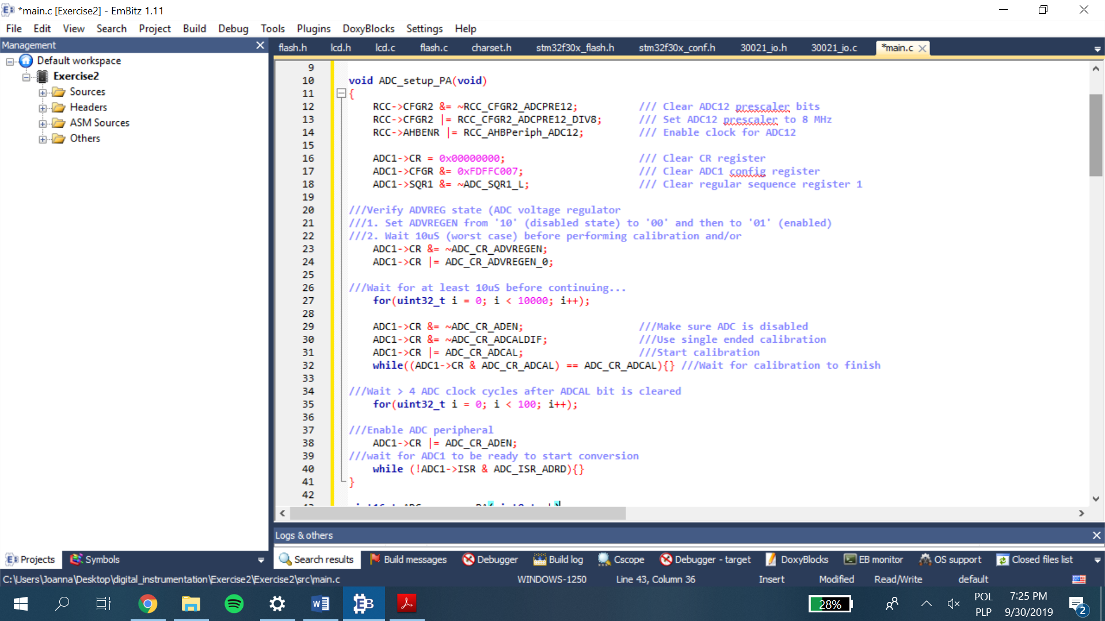

Code 8. ADC_setup_PA() function.

Second function, called *ADC_measure_PA()* includes commands which start measuring and convert obtained value of ADC:

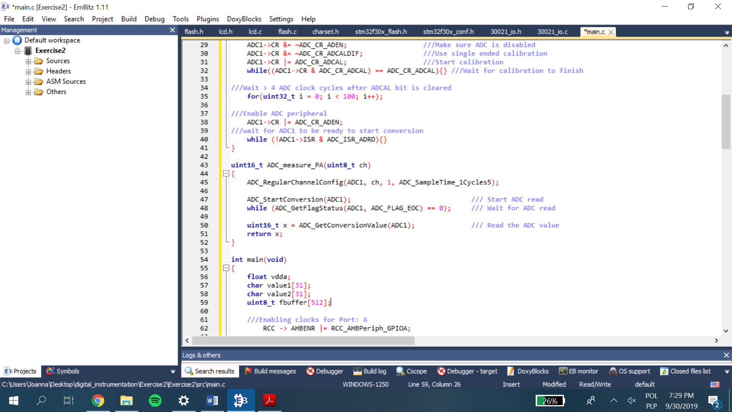

Code 9. ADC_measure_PA(uint8_t ch) function.

In the main part of the program, it is enough to call these two function and then, in while loop, the measurements from both ADCs are extracted and displayed in the LCD:

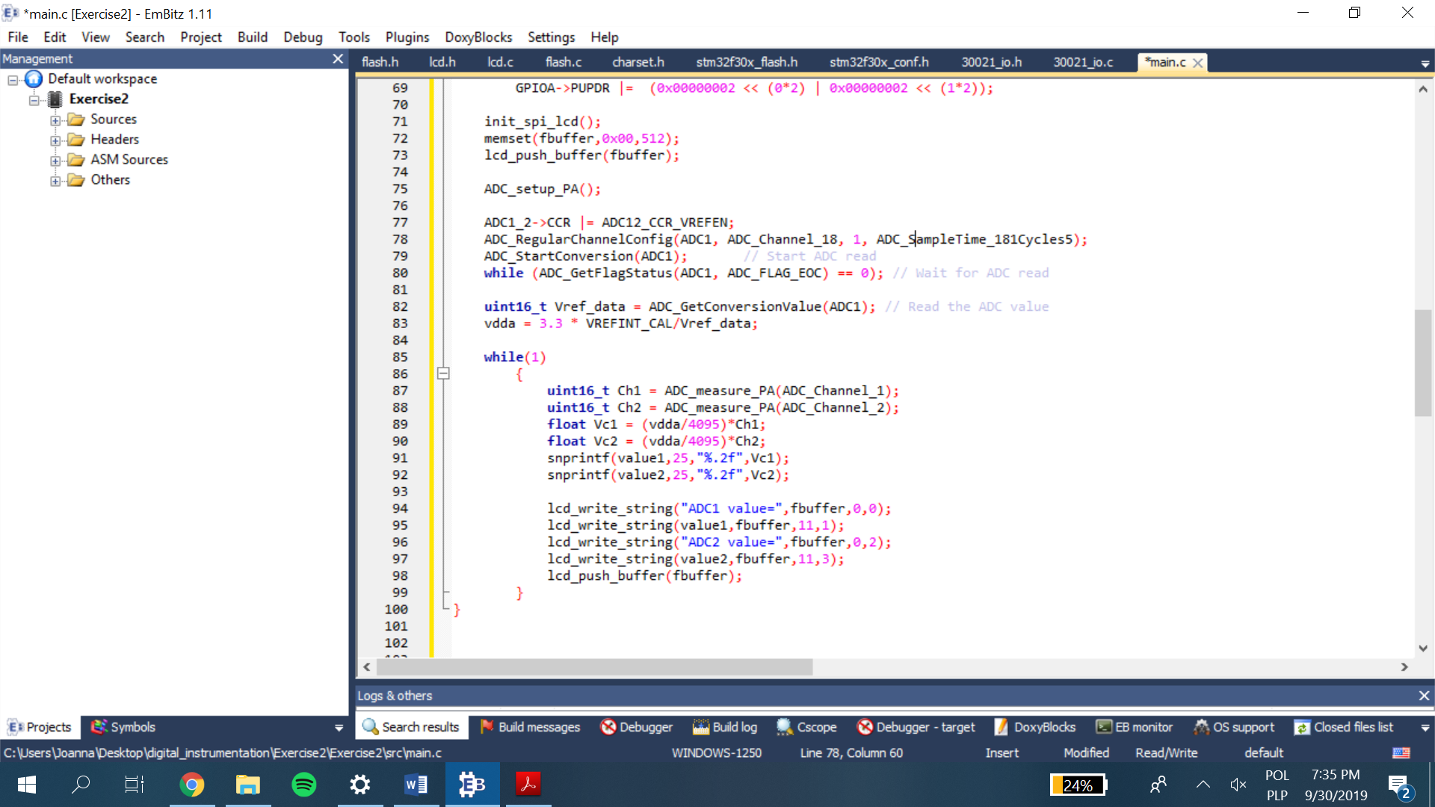

Code 10. Presenting measured voltage values.

The above code displays the voltage values in PA0 and PA1 obtained in ADC1 and ADC2 respectively in the LCD.

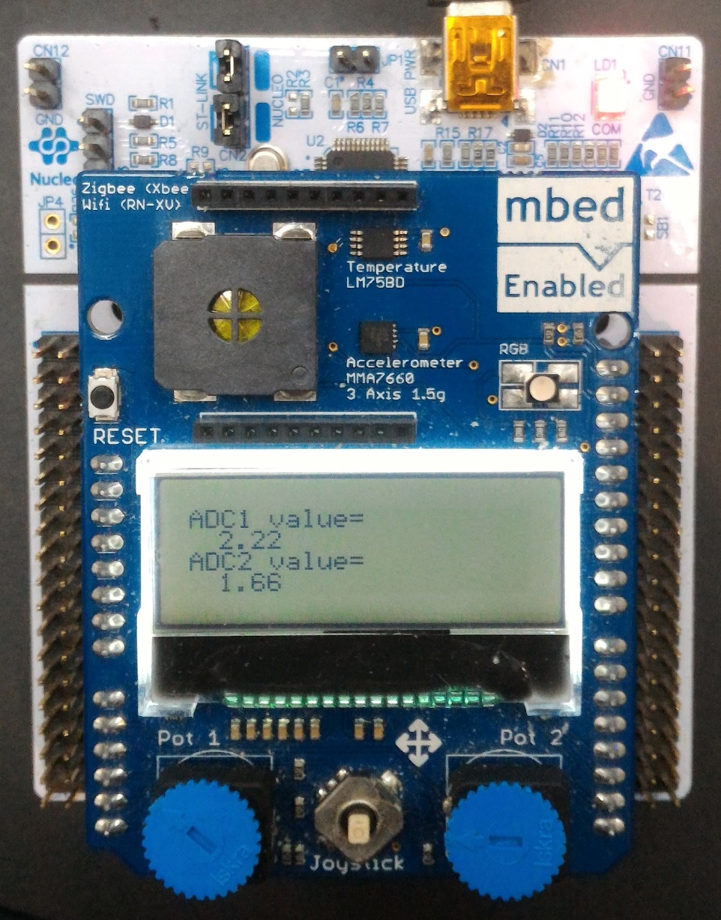

Picture 7. Presentation on the LCD.

**Exercise 2.3 – Absolute voltage from ADC measurement**

**Implementation:**

On the board, the reference voltage is connected directly to the analog power supply pin (VDD). According to this, in perfect situation, Vdd should be equal to 3,3V and be a result of the following formula:

In practice, however, set Vrefint_cal is slightly different to the Vrefint_data value which is being measured. To calculate and store both Vrefint_data and Vdd values, two lines have been added to the *main()* function:

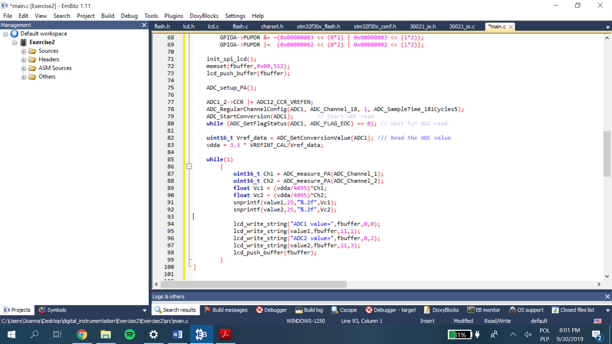

Code 11. Real Vdd calculations.

This calculation presents a little higher voltage than supposed 3,3 V:

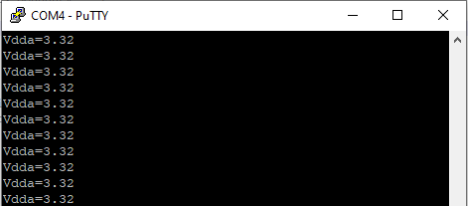

Picture 8. PUTTY window.

**Calculation of correct sample time:**

ADC clock frequency – 8 MHz

Conversion time – 15 cycles

$$t_{s}=\frac{t_{c}}{f_{ADC_{clk}}}=\frac{15}{8*{10}^{6}}=1,875 [μs]$$

**Step size:**

$$\frac{3.32}{4096}=0.81 mV$$

**Absolute value of the ADC:**



Picture 9. Presentation on the LCD.

**Exercise 2.4 – Calibrate the ADC measurement**

In this exercise, the voltage measurement made using the ADC is compared with the true values at the input ports with the use of a digital multi-meter and the error in measurements are reduced.

1. **Finding the calibration factor and error correction:**

* The ADCs are adjusted to a fixed voltage of 3.2V. Now the voltage at input pins A0 and A1 both are measured one by one using the multimeter.

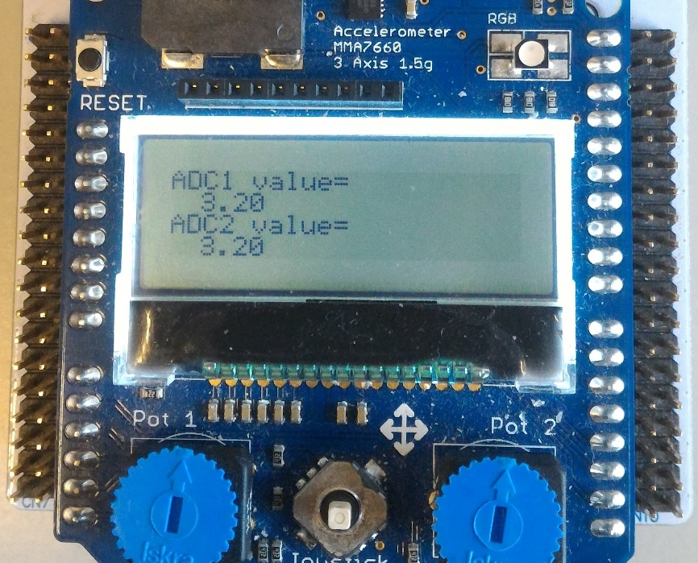

Picture 10. ADC values set to 3.2V using potentiometers.

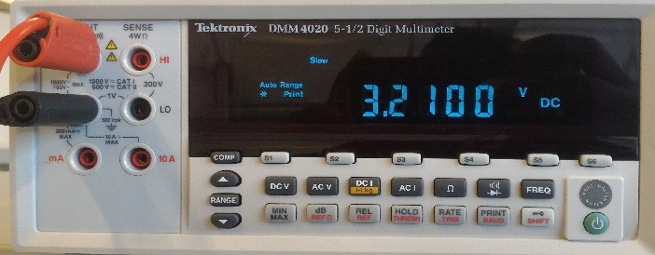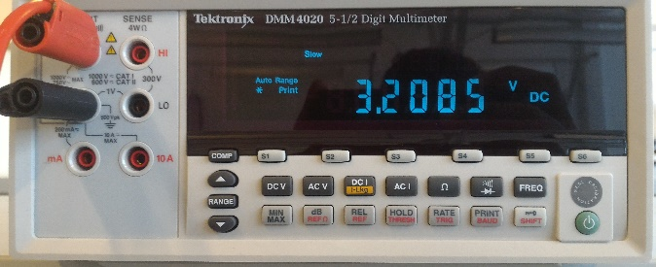

*Picture 11. Multimeter reading of A0 and A1 respectively.*

* The deviation is noted down and we introduce a calibration factor, which corrects the erroneous data in the program.
* The value of calibration factor is displayed, along with the corrected data in the LCD.

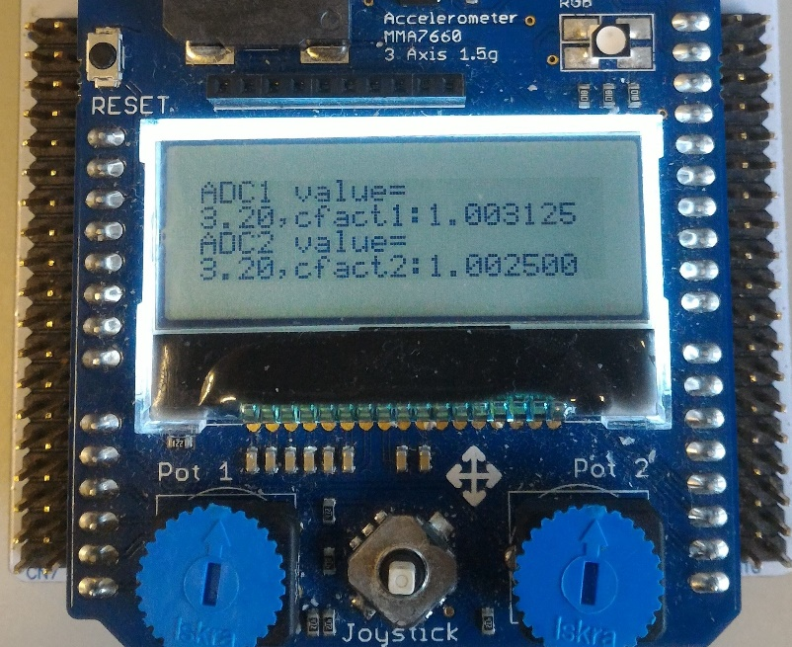

*Picture 12.Calibrated values of ADCs with the calibration factors.*

* The correction factors are stored in flash memory and used for the program when required.

1. **Assessment of correction factor:**

* To assess the calibrated ADC’s performance, we adjust the potentiometer to set the value of ADC measured voltage to 3.00V.
* Now, the voltage at A0 and A1 are measured using the multimeter.

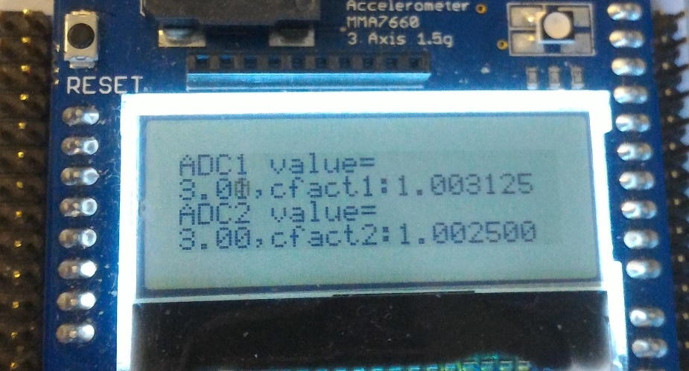

*Picture 13. Final voltage measurement of ADC1 and ADC2.*

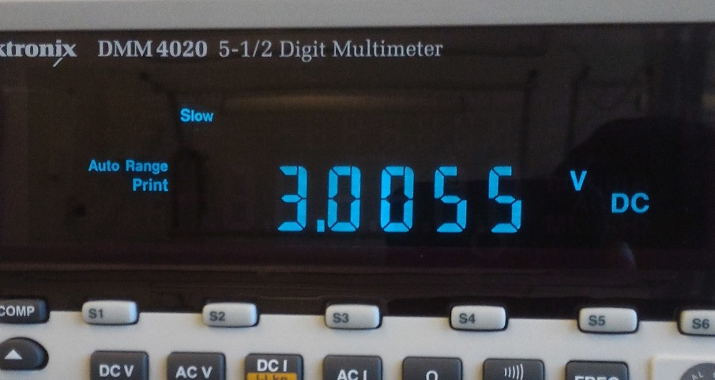

*Picture 14.Potentiometer values of A0 and A1.*

* It is evident that the new value displayed in the multimeter gives better precision than the previous values.

The calibration factors are stored in flash memory and read inside the while loop when thay are needed, using the following steps.

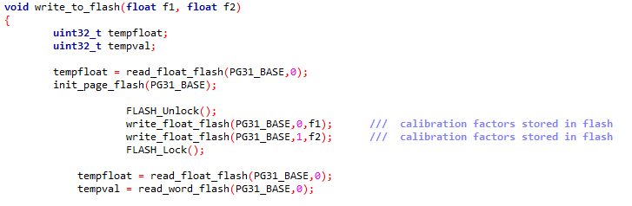*Picture 15.Calibration factors stored in flash.*

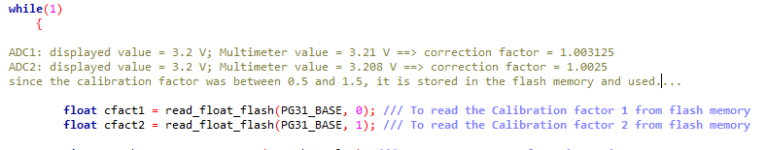

*Picture 16.Calibration factors read from flash*

Setup ADC

Write factors to FLASH

Read calibration factors from (1 and 2) from the memory

Measure and store measured ADC1 and ADC2 values

Start/Reset

Set SPI and/or UART connection

Display both ADC values

Configurate potentiometers’ pins

Char 4. Analog to digital conversion, measurement and calibration of voltage

**Conclusion**